# Predicting while Moving: How Visually Simulated Self-Motion Impacts the Prediction of Object Motion

Björn Jörges¹*, Laurence R. Harris¹

¹ Center for Vision Research, York University, 4700 Keele Street, Toronto, ON M3J 1P3, Canada

* Corresponding Author

# Abstract

To interact successfully with moving objects in our environment we need to predict their behavior. Predicting the trajectory of such object requires, in turn, estimates of their velocities. When flow parsing during self-motion is incomplete, that is, when parts of the retinal motion caused by self-motion are attributed to object motion, the velocities estimates can be biased. Further, the process of flow parsing may lead to velocity judgements being more variable during self-motion. Biases and lowered precision in velocity estimation should then translate to biases and lowered precision in motion prediction. We investigate this relationship between self-motion, velocity estimation and motion prediction with two tasks in a realistic VR environment: first, participants are shown a ball moving laterally which disappears after a certain time. They then have to indicate by button press when they think the ball would hit a target rectangle in the environment. While the ball is visible, they can experience visual lateral self-motion in the same or in the opposite direction of the ball or they remain static. The second task is a two-interval forced choice task in which participants have to judge which of two motions is faster: one consists in the same ball they observe in the first task, while the other consists in a ball cloud whose speed is controlled by a PEST staircase. While observing the single ball, they are again moved visually either in the same or opposite direction of the ball or they remain static. We expect participants to overestimate the speed of a ball that moves opposite to the simulated self-motion (speed estimation task), which should lead them to underestimate the time it takes the ball to reach the target rectangle (motion prediction task). Visually simulated self-motion should further increase variability in both tasks. We expect to find performance to be correlated between both tasks, both in terms of accuracy and precision.

# Introduction

We are constantly immersed in complex, dynamic environments that require us to interact with moving objects, for example when passing, setting, and hitting a volleyball, or deciding whether we can make a safe left-turn before another car reaches the intersection. In such situations, it can often be important to predict how objects in our environment will behave over the next few moments. Predictions allow us, for example, to time our actions accurately despite neural delays (DiCarlo & Maunsell, 2005; Maunsell & Gibson, 1992; Schmolesky et al., 1998) in perceiving moving objects and issuing and executing motor commands (de Rugy, Marinovic, & Wallis, 2012; Zago, McIntyre, Senot, & Lacquaniti, 2008). Delays between 100ms and 400ms between visual stimulation and motor response are generally assumed (Foxe & Simpson, 2002). Without predicting or anticipating motion, we would thus always act on outdated positional information and, for example when attempting to intercept fast moving objects. Further, and perhaps more obviously, predictions are also important when moving objects are occluded during parts of their trajectory (Jörges & López-Moliner, 2019; Kreyenmeier, Fooken, & Spering, 2017; Spering, Schutz, Braun, & Gegenfurtner, 2011), or when the observer can’t keep their eyes on the target continuously.

When the observer themselves is moving while attempting to interact with moving objects in their environment, further difficulties arise. Even in the simplest case, when predictions are largely unnecessary, the visual system needs to separate retinal motion due to observer motion from retinal motion due to object motion in order to judge an objects trajectory accurately. A prominent hypothesis on how this is achieved is the Flow Parsing hypothesis (Dupin & Wexler, 2013; Rushton & Warren, 2005; Warren & Rushton, 2007, 2008, 2009). This hypothesis states that, to solve this problem, humans first estimate their self-motion. Based on this estimate, they compute which parts of the experienced optic flow is caused by their own movement. This optic flow component is then subtracted from the global optic flow, and the remaining optic flow is attributed to object motion. This process thus relies on estimating self-motion accurately, and any biases in self-motion speed estimates should translate to biases in object speed estimates. There is further some evidence that integrating noisier self-motion estimates (Fetsch, Deangelis, & Angelaki, 2010) with optic flow information in this fashion should lead to noisier object motion estimates when more self-motion is parsed out (Dokka, MacNeilage, DeAngelis, & Angelaki, 2015).

Self-motion perception is a multisensory process where visual, vestibular, proprioceptive, and other cues (Durgin, Gigone, & Scott, 2005; Dyde & Harris, 2008; Hogendoorn, Alais, MacDougall, & Verstraten, 2017; Kapralos, Zikovitz, Jenkin, & Harris, 2004; MacNeilage, Zhang, DeAngelis, & Angelaki, 2012; Redlick, Jenkin, & Harris, 2001) are integrated according to their relative reliabilities (Butler, Campos, & Bülthoff, 2014; Campos, Butler, & Bülthoff, 2012; Fetsch et al., 2010). In the case of visually simulated, passively experienced self-motion (as for example in some VR applications) vestibular and proprioceptive cues would signal that the body is at rest, while the visual optic flow cues would indicate self-motion. Integrating these cues may thus lead the observer to underestimate self-motion. This in turn should lead to biases in the perception of object motion during self-motion. And in fact, biases consistent with this reasoning have been found in numerous studies for different types of motion (Dyde & Harris, 2008; Garzorz, Freeman, Ernst, & MacNeilage, 2018; Gray, MacUga, & Regan, 2004; Hogendoorn et al., 2017; Kreyenmeier et al., 2017; Probst, Loose, Niedeggen, & Wist, 1995).

Figure 1: Schematic of the processes at play when predicting motion during self-motion.

Figure 1 shows a simple schematic of the processes we assume to be at play when predicting object motion during self-motion: the organism first estimates its own motion in the environment from the various sources of information available to it. Based on this self-motion estimate, it would then make a prediction about the retinal motion this self-motion entails. The predicted retinal motion is subtracted from the total retinal motion observed online and any remaining motion is attributed to the object. The further motion of the object would then be predicted based on this estimate of the object velocity.

Some studies suggest that biases incurred while estimating motion, e.g., due to the Aubert-Fleischl effect (Jörges & López-Moliner, 2020), or due to low contrast in the stimulus (de’Sperati & Thornton, 2019), may translate to motion prediction. In this study, we investigate how biases in speed estimation elicited by visual self-motion impact the prediction of object motion.

More specifically, we will test three hypotheses:

* Motion prediction should be biased (Hypothesis 1a) and more variable (Hypothesis 1b) in response to visual self-motion
* Object speed estimates should be biased (Hypothesis 2a) and more variable (Hypothesis 2b) during visually simulated self-motion
* We can predict the effect of visual self-motion on motion prediction from its effect on speed estimation, both in terms of bias (Hypothesis 3a) and variability (Hypothesis 3b)

# Methods

## Apparatus

We programmed all stimuli in Unity 2020.14.3. Given the on-going COVID-19 pandemic, some participants who are owners of head-mounted VR devices (HMDs) will be tested in the safety of their home. Our experiment is compatible with all major modern HMDs. If it is safely possible and an ethics approval is granted, we might also test some participants in person. For these participants, we will use an Oculus Rift S.

## Participants and Recruitment

We recruit participants with HMDs in their possession online for them to perform the experiment in their homes. Recruitment will occur through social media (such as Twitter, Facebook, and Reddit). Some remote participants might also be recruited through the professional recruitment service XpertVR. Since recruiting participants with VR equipment at home is not trivial, we might also rely on York University participant pools to recruit participants for in-person testing. In this case, all applicable guidelines for safe face-to-face testing will be fulfilled and exceeded. Participants receive a monetary compensation of 45 CAD for participation in the experiment; participants recruited through the York University participant pools may receive course credit instead of a monetary compensation. All participants are screened for stereo-blindness with a custom Unity program ([downloadable here, on GitHub](https://github.com/b-jorges/Stereotest)) in which participants have to distinguish the relative depth of two objects that are matched in retinal size. Participants are only included if they answer correctly on 16 out of 20 trials. The simulated disparity is 200 arcsec. While this allows only for a coarse assessment of the participants’ stereovision, our experiment is not critically dependent on a high stereoacuity. We will test 20 men and 20 women (see Power Analysis). The experiment was approved by the local ethics committee and will be conducted in accordance with the Declaration of Helsinki.

## Stimulus

Each participant performs two main tasks in an immersive VR environment: a prediction task and a speed estimation task. You can download all programs we used to present the stimuli [here (on Open Science Foundation)](https://osf.io/gakp5/), and the Unity projects can be downloaded [here (on Open Science Foundation)](https://osf.io/6mz4w/).

**Motion Prediction** – In the prediction task (see Figure 2A, and see also [this video on YouTube](https://www.youtube.com/watch?v=phratRswyao&ab_channel=Bj%C3%B6rnJ%C3%B6rges)), we first show participants a ball of 0.4 m diameter moving laterally 8m in front of them at one out of three speeds (4, 5, 6 m/s). The ball can travel to the left or to the right. It appears to the left of the observer when it travels to the right, and on the right of the observer when it travels to the left, such that the trajectory is centered in front of the observer. At the same time, a target rectangle is presented on the side towards which the ball is travelling. The ball disappears after 0.5s and participants have to press the space bar on their keyboard when they think the ball would hit the target. The target is presented at a distance corresponding to the speed of the ball and one out of three occlusion durations (0.5 s, 0.6 s, 0.7 s). The distance between the point where the ball disappears (“point of disappearance” in the following; see Figure 2C) and the target is thus given by the following equation:

|  |  |
| --- | --- |
| $$Distance= Duration_{Occlusion}*Speed_{Ball}$$ | [1] |

While the target is visible, participants can experience lateral visual self-motion either in the same direction as the ball or in the opposite direction of the ball, or they can remain static. The self-motion speed is simulated with the profile of a normal Gaussian distribution, such that the distance over time is given by the following equation:

|  |  |
| --- | --- |
| $$Distance_{Self-motion}\left(t\right)= 2t*\frac{1}{0.12*\sqrt{2π}}*e^{-\frac{1}{2}{\left(\frac{t-0.25}{0.12}\right)}^{2}}$$ | [2] |

The observer thus accelerates, reaches a peak velocity of 6.6 m/s after 0.25s and decelerates again. They travel 1.8 m over the course of 0.5 s for an average self-motion speed of 3.6m/s.

We further add longer and shorter occlusion durations (0.1s, 0.2s, 0.3s, 0.4s, 0.8s, 0.9s, 1s) where the observer is static to get a notion of how variability changes in response to different occlusion durations. Overall, participants thus complete 225 trials (3 ball speeds * 3 self-motion profiles * 3 occlusion durations * 5 repetitions + 3 ball speeds * 6 occlusion durations * 5 repetitions), which takes around 10 minutes.

Participants also complete a brief training of 18 trials before starting the main experiment (see [this video on YouTube](https://www.youtube.com/watch?v=iAfY7mxEqSI&ab_channel=Bj%C3%B6rnJ%C3%B6rges)). The ball travels at one out of three speeds (2.5, 3.5, 4.5 m/s), going either left or right, and three occlusion durations (0.45, 0.55, 0.65 s). In the training, the ball reappears upon pressing space in the position it would have been in that moment. This allows participants to estimate their error (spatially) and helps them familiarize themselves with task and environment.

|  |  |
| --- | --- |
|   **A** |   **B** |
| **C** | **D** |

Figure 2: **A**. Screenshot from the motion prediction task while the ball was visible. **B**. Screenshot from the speed estimation task while the ball cloud was presented. **C**. Schematic of the motion prediction task. **D**. Schematic of the speed estimation task.

**Speed estimation –** In the speed estimation task ([video on YouTube](https://www.youtube.com/watch?v=05JA19xoieY&ab_channel=Bj%C3%B6rnJ%C3%B6rges)), participants are presented with two motion intervals and have to judge which of them is faster. In one of them, they view a ball travelling to the left or to the right. As for the motion prediction task, this ball can have one out of three speeds (4, 5, 6 m/s), and the participant can also experience visual self-motion in the same direction or in the opposite direction, or remain static (see Figure 2D). The second motion consists of a ball cloud of 2.5 m width and 1 m height at the same distance to the observer (see Figure 2B). Each ball in this cloud has the same diameter as the main target (0.4m) and balls are emitted randomly from one side of the cloud area such that, at any given moment, between 8 and 12 balls are visible. All balls move at the same speed and are visible either until they reach the opposite end of the cloud area or until the motion interval ends after 0.5s observation time. The speed of these balls is constant throughout each trial and is governed by PEST staircase rules (Taylor & Creelman, 1967). For each condition, we employ two pests: one starts 30% above the speed of the single ball from the other motion interval, while the other starts 30% below. The initial step size is 0.6 m/s and each pest terminates either after 37 trials, or when the participant has completed at least 30 trials and the step size drops below 0.03 m/s. We modified the original PEST rules such that the step size is always twice the initial step size (that is, 1.2 m/s) for the first ten trials in order to spread out the values presented to the observer and allow for more robust JND estimates. We limit the range of speeds the ball cloud can take to between one third the speed of the ball and three times the speed of the ball. Overall, participants perform 30 to 37 trials in 18 staircases (two start values, three speeds and three motion profiles) for a total of 540 to 666 trials.

Before proceeding to the main task, participants are asked to complete a training session. This training session consists of one PEST of reduced length (between 20 and 27 trials) that starts 30% above the speed of the ball (3 m/s). Participants need to achieve a final step size of below 0.3; otherwise they are asked to repeat the training. If they fail the training a second time, we exclude them from the analysis. This task – including the training – takes about 40 minutes to complete.

Participants can choose to receive the instructions as PDF ([can be downloaded here, from GitHub](https://github.com/b-jorges/Predicting-while-Moving/blob/main/Instructions%20Predicting%20while%20moving.pdf)) or watch a video ([which can be viewed here, on YouTube](https://www.youtube.com/watch?v=7EA21uNC5Rw&ab_channel=Bj%C3%B6rnJ%C3%B6rges)).

## Predictions

We built models of the underlying perceptual processes for both the prediction and the speed estimation task. The instantiation of the model for the prediction task can be found [here (on GitHub)](https://github.com/b-jorges/Predicting-while-Moving/blob/main/Analysis%20Prediction.R), and the instantiation of the speed estimation model can be found [here (on GitHub)](https://github.com/b-jorges/Predicting-while-Moving/blob/main/Analysis%20Speed%20Estimation.R). The implementation of the model that relates performance in both tasks can be found [here (on GitHub)](https://github.com/b-jorges/Predicting-while-Moving/blob/main/Predictions%20Correlations.R). The models are based on the following assumptions:

* The time it would take the ball to reach the target rectangle was underestimated by an amount corresponding to 20% of the presented self-motion speed for the Opposite Directions motion profile (Jörges & Harris 2021), with a between-participant standard deviation of 30% for this bias. No biases were assumed for the Same Directions and Observer Static motion profiles.
* The variability in responses was 20% higher in the Opposite Directions motion profile, with a between-participant standard deviation of 30% for this effect. No differences in variability were assumed for the Opposite Directions and Static motion profile.
* Participants estimated the ball speed accurately in the Same Direction and Static motion profile.
* A Weber Fraction of 10% for the estimation of the ball speed, with a between-participant standard deviation of 1.5%.
* The distance between the point of disappearance of the ball and the target rectangle was estimated accurately with a Weber Fraction of 5%. No between-participant variability was assumed here.
* *Prediction only:* The computations executed by the visual system are approximated accurately with the physical equation for distance from speed and time (d = v*t), such that the extrapolated time ($t_{extrapolated}$) can be estimated from the distance between the point of disappearance and the target ($d_{perceived}$) and the perceived speed of the ball ($v_{perceived}$):

|  |  |
| --- | --- |
| $$t_{extrapolated}=d_{perceived}/v_{perceived}$$ | (3) |

* Effects of self-motion on mean perceived speed and variability of perceived speed are drawn per participants and are assumed to be constant across both task for each participant. The normal distributions from which these per-participant effect strengths are drawn have means of 0.2 and standard deviations of 0.3. This is in accordance with our previous results (Jörges & Harris, 2021) which showed a considerable amount of variability in the strength of the effect.

**Motion Prediction** – For the motion prediction task, under these assumptions, participants would respond between 0.12 and 0.2s earlier in the Opposite Direction motion profile with regards to the Static motion profile (see Figure 3A). Our generative model further predicts that visual self-motion during motion observation to lead to higher variability in responses. Measuring the relation between self-motion and variability is not straight-forward because self-motion should cause an underestimation of the occlusion duration. A shorter predicted interval should in turn be related to lower variability in absolute terms. Figure 3B illustrates the expected relationship between biases in prediction, the motion profile and variability in responses.

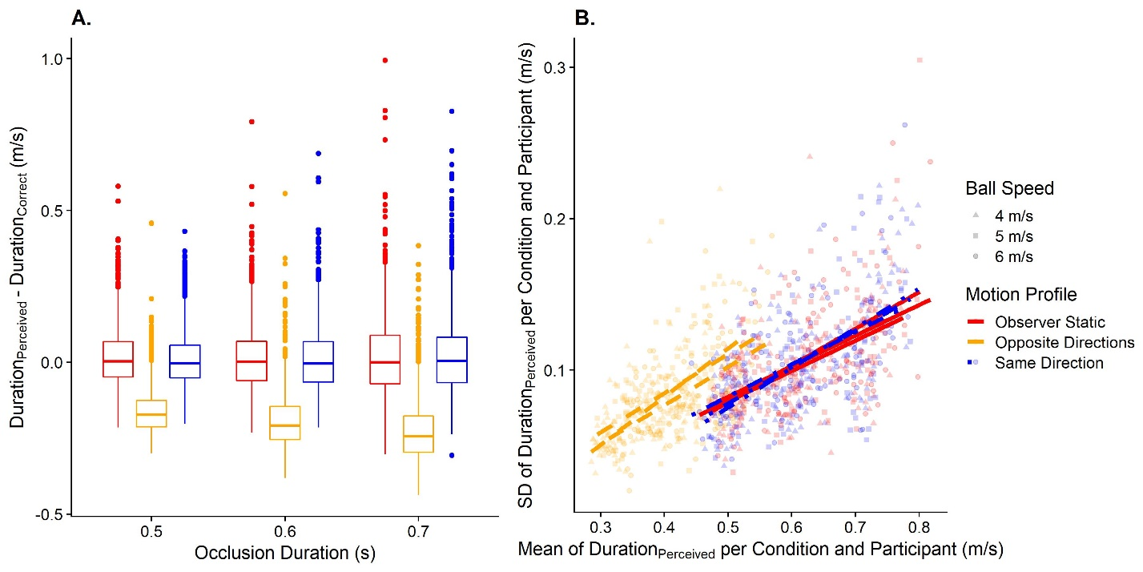

Figure 3: A. Predicted data for the timing error in the prediction task, divided up by occlusion durations (x axis) and motion profile (color-coded; left-most: “Observer Static”; in the middle: “Opposite Directions”; right-most “Same Directions”). B. Predicted data for variability in the prediction task. The y axis displays the standard deviation of the extrapolated duration per condition and participant, while the x axis corresponds to the mean of the extrapolated duration per condition and participant. The motion profile is coded with different colors and linetypes (red and continuous for “Observer Static”, yellow and dashed for “Opposite Directions” and blue and dashed-and-dotted for “Same Direction”).

**Speed estimation** – Here, we expect to replicate our findings reported in (Jörges & Harris 2021): We found that participants largely estimated speed at the same accuracy when they were static and when they were moving in the same direction as the target. Visually simulated self-motion in the opposite direction of the ball should lead to an overestimation of ball speed (Hypothesis 2a; see Figure 4A). Since we use a higher self-motion speed than in our previous study, we also expect to find evidence that precision will be lower for visual self-motion in the opposite direction of the ball (Hypothesis 2b, see Figure 4B).

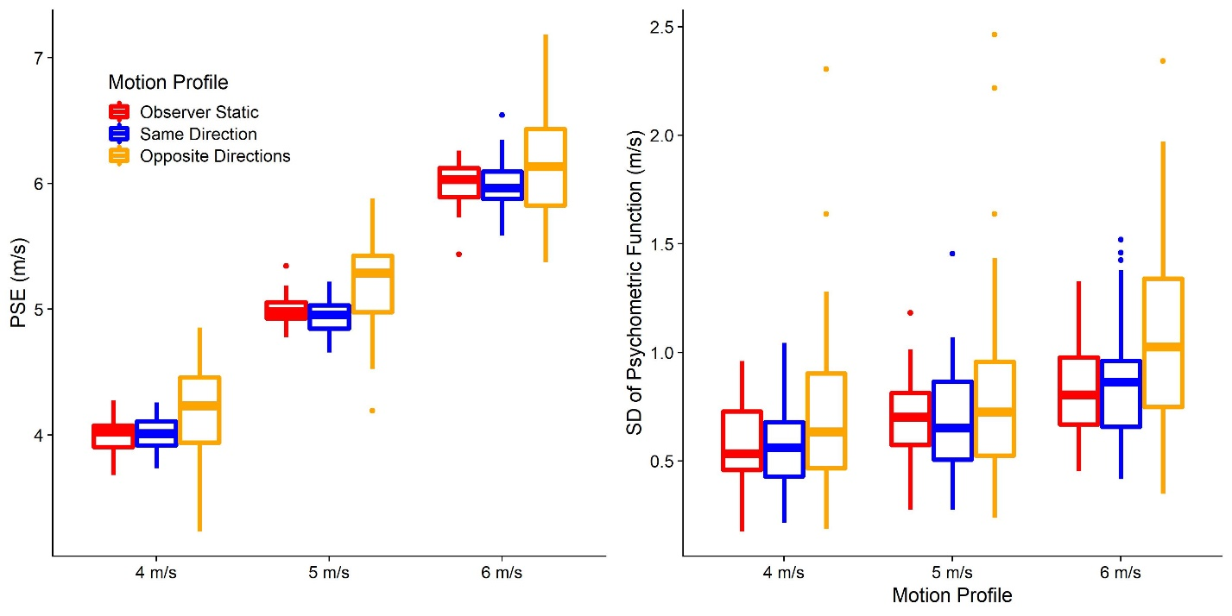

Figure 4. A. Predicted PSEs (y axis) for each ball speed (x axis) and motion profile (color-coded; left-most: “Observer Static”; in the middle: “Opposite Directions”; right-most “Same Directions”). B. As A. but for the predicted JNDs.

**A link between speed estimation and motion prediction** – We further expect the errors observed in the motion prediction task in response to self-motion to correlate with the errors in the speed estimation task in response to self-motion, indicating that performance in speed perception translate to errors in motion prediction, both in terms of accuracy (Figure 5A) and precision (Figure 5B).

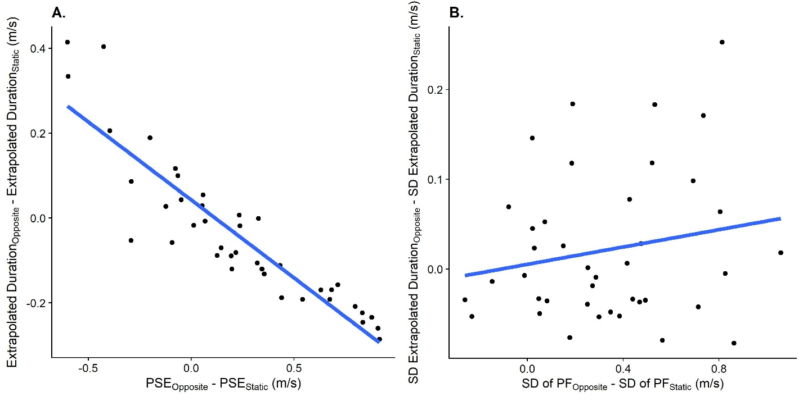

Figure 5: A. Relationship between the difference in PSEs between the Opposite Directions motion profile and the Observer Static motion profile in the speed estimation task (x axis) and the difference in predicted durations between these motion profiles (y axis). One data point corresponds to one participant. B. As A., but for the relation between the JND differences in the speed estimation task between the “Opposite Directions” motion profile and the “Observer Static” motion profile and the differences in standard deviations between these motion profiles.

## Data analysis plan

We first perform an outlier analysis. For the prediction task, we exclude all trials where the response timing was more than three times the occlusion duration, which indicates that the participant has not paid attention and missed the trial. For the speed estimation task, we exclude participants where more than 20% of presented ball cloud speeds were at the limits we set for the staircase (one third of the ball speed and three times the ball speed). For all analyses related to precision, we further exclude all conditions where we obtained a standard deviation of 0.01 or lower. According to our simulations, this should occur very rarely, and taking the log of such low values, as we do for the precision analyses to counteract the expected skew in these distributions, would lead to extremely small numbers that could bias results unduly.

Unless noted otherwise, we compute bootstrapped 95% confidence intervals as implemented in the confint() function for base R (R Core Team, 2017) to determine statistical significance.

**Motion Prediction** – To test Hypotheses 1a regarding accuracy, we use Linear Mixed Modelling as implemented in the lme4 package (Bates, Mächler, Bolker, & Walker, 2015) for R. The corresponding script can be found [here (on GitHub)](https://github.com/b-jorges/Predicting-while-Moving/blob/main/Analysis%20Prediction.R). We fit a model with the temporal error as dependent variable, the motion profile (“Observer Static”, “Same Direction” and “Opposite Directions”) as fixed effect, and random intercepts and random slopes for the speed of the ball per participant, as well as random intercepts for the occlusion duration as random effects. In Wilkinson & Rogers notation (1973), this model reads as follows:

|  |  |
| --- | --- |
| *+ (1 | Occlusion Duration)* | (4) |

For Hypothesis 1b regarding precision, we need to take into account that biases in the timing error can impact variability. That is, overestimating the time it takes the ball to hit the rectangle could be connected to a higher variability in absolute terms, while underestimating the time could lead to lower variability. For this reason, we first compute the means and standard deviations of extrapolated durations for each condition and participant. We then fit a test model with the standard deviations as dependent variable, the mean timing error and the motion profile as fixed effects, and random intercepts as well as random slopes for ball speeds per participant and random intercepts for the occlusion durations as random effects:

|  |  |
| --- | --- |
| *+ (1 | Occlusion Duration)* | (5) |

We further fit a null model without the motion profile as fixed effect:

|  |  |
| --- | --- |
| *+ (1 | Occlusion Duration)* | (6) |

We then compare both models by means of a Likelihood Ratio Test to determine whether the motion profile explains significantly more variability than the test model which already takes into account biases in extrapolated time.

**Speed Estimation** – To test Hypotheses 2a and 2b (script can be found [here, on GitHub](https://github.com/b-jorges/Predicting-while-Moving/blob/main/Analysis%20Speed%20Estimation.R)) regarding speed estimation, we first use the R package quickpsy (Linares & López-Moliner, 2016) to fit psychometric functions to the speed estimation data, separately for each participant, speed and motion profile. Quickpsy fits cumulative Gaussian functions to the data by direct likelihood maximization. The means of the cumulative Gaussians correspond to the Points of Subjective Equality (PSEs) and their standard deviations correspond to the 84.1% Just Noticeable Differences (JNDs).

To assess whether the motion profile impacted the perceived speed significantly, we fit two Linear Mixed Models. One has the PSEs as dependent variable, the self-motion profile as fixed effect, and random intercepts and random slopes for the ball speed per participant as random effects. The other model has the same set-up of fixed and random effects, but with log JNDs as dependent variable:

|  |  |
| --- | --- |
|  | (7) |
|  | (8) |

**A link between speed estimation and motion prediction** – To test Hypotheses 3a and 3b (script can be found [here, on GitHub](https://github.com/b-jorges/Predicting-while-Moving/blob/main/Analysis%20Correlation.R)), we first prepare the prediction data by computing means and standard deviations of the extrapolated time for each participant. We then calculate the difference in performance (mean and standard deviations for the prediction task and PSEs and JNDs for the speed estimation task) between the “Opposite Directions” motion profile and the “Observer Static” motion profile for both tasks for each participant.

For accuracy, we then determine to what extent PSE differences between the Opposite Direction motion profile and the Observer Static motion profile obtained in the speed estimation task predict the mean extrapolated time in the prediction task. For this purpose, we fit a Linear Model with the difference in mean motion prediction errors between the motion profiles as dependent variable and the difference in PSEs between the motion profiles as independent variable:

|  |  |
| --- | --- |
| $$Mean Difference in Extrapolated Time (Opposite-Static) \sim PSE Difference$$ | (9) |

For precision, the same complication as for Hypothesis 1b applies: A correlation between the effect of visual self-motion on the precision of speed estimation and on the precision of motion prediction could be due to biases introduced by visual self-motion. If visual self-motion in the opposite direction, for example, leads to too-early responses, the extrapolated intervals is shorter. A shorter interval, in turn, should lead to higher precision in absolute terms. Therefore, to test whether the difference in precision observed in the speed estimation task was significantly related to the variability in the prediction task even after accounting for biases, we need to determine whether the effect of visual self-motion on JNDs predicts any variability beyond the variability that is already explained by the bias in motion extrapolation. To this hypothesis, we first fit a test model with the variability difference between the “Opposite Directions” motion profile and the “Observer Static” motion profile in the motion prediction task as dependent variable and the mean difference between these motion profiles and the difference in JNDs in the speed estimation task as independent variables (as a measure of bias introduced by visual self-motion):

|  |  |
| --- | --- |
| $$Variability Difference in Extrapolated Time \left(Opposite-Static\right)\sim Mean Difference in Extrapolated Time \left(Opposite-Static\right)+JND Difference$$ | (10) |

We also fit a null model without the JND difference as independent variable:

|  |  |
| --- | --- |
| $$Variability Difference in Extrapolated Time \left(Opposite-Static\right)\sim Mean Difference in Extrapolated Time \left(Opposite-Static\right)$$ | (11) |

Then, we use a Likelihood Ratio Test to determine whether the test model (with the JND difference as fixed effect) was significantly better than the null model.

**An effect of visual self-motion in the same direction as the ball** – While our earlier results (Jörges & Harris 2021) suggest that visual self-motion in the same direction as the observer should not have any effect on perceived speed, we perform all analyses outlined in this section equivalently for the “Same Direction” motion profile as well.

## Power analysis

Since power for complex hierarchical designs cannot be computed analytically, we used Monte Carlo simulations to determine power for all statistical tests outlined in the previous section: we used our generative models for the prediction task and the speed estimation task to first simulate full datasets. Then, we performed the analyses detailed above over each of these datasets and determined the results for each combination of number of participants and number of trials. To keep the computational cost manageable, we used the faster, but more bias-prone Satterthwaite approximation, as implemented in the lmerTest package (Kuznetsova, Brockhoff, & Christensen, 2017) for R, to assess statistical significance rather than bootstrapped confidence intervals. The script used for the power analyses can be found [here (on GitHub)](https://github.com/b-jorges/Predicting-while-Moving/blob/main/Power%20Analysis.R).

We repeated this process 250 times for all combinations of 20, 30 and 40 participants, 5, 9 and 13 repetitions per condition in the prediction task, and 20 to 27, 30 to 37, and 40 to 47 trials per pest, which makes for an average of 50, 70 and 90 trials per condition, respectively, for the speed estimation task. The results are shown in Figure 6. For the precision in the prediction task, using 9 repetitions per condition appears to add a considerable amount of power with regards to 5 repetitions, while the added benefit of another 4 repetitions for a total of 13 is small. However, the prediction task is very short, with around 10 minutes even with 13 repetitions per condition. Similarly, 70 trials per condition increases the power to detect the effect on precision by a relevant amount over 50 trials, while the added benefit of 90 trials is marginal. Since the speed estimation task takes much longer and is more fatiguing than the prediction task, this marginal amount of added power is not worth the additional time spent by the participant. We thus opt for a combination of 40 participants, 13 repetitions per condition in the prediction task and 70 trials per condition in the speed estimation task, which allows us to achieve a power of at least 0.85 for all statistical tests.

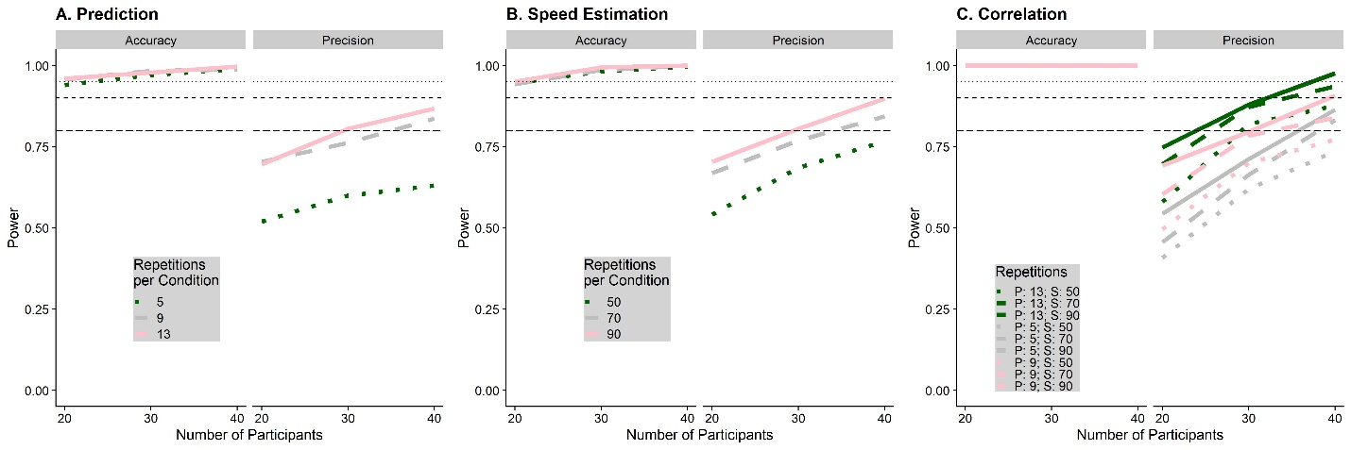

Figure 6: Simulated power for the prediction task (A), the speed estimation task (B) and the correlation between performance in speed estimation and speed prediction (C), separately for the statistical tests referring to biases (accuracy) and variability (precision). The number of participants for which we simulated power is on the x axis, while the number of trials for each task is coded with different shades of green and line types. The horizontal lines indicate a power level of 0.8, 0.9 and 0.95 respectively.

We also used our power analyses to determine that all of our statistical analyses led to an expected false positive rate of 0.05 in absence of a true effect.

# Acknowledgements

BJ and LRH are supported by the Canadian Space Agency (CSA) (CSA: 15ILSRA1-York). LRH is supported by a Discovery Grant from the Natural Sciences and Engineering Research Council (NSERC) of Canada (NSERC: RGPIN-2020-06093). The funders did not play any role in the study design, data collection and analysis, decision to publish, or preparation of the manuscript.

# Competing Interests

The authors declare no competing interests.

# Data Availability and Open Science

All scripts and all data obtained with regards to this project will be made available in the [project GitHub repository](https://github.com/b-jorges/Predicting-while-Moving/). Larger files such as the programs used to present stimuli and the respective Unity projects are [hosted on OSF](https://osf.io/eayf7/).

Bates, D., Mächler, M., Bolker, B. M., & Walker, S. C. (2015). Fitting linear mixed-effects models using lme4. *Journal of Statistical Software*, *67*(1). https://doi.org/10.18637/jss.v067.i01

Butler, J. S., Campos, J. L., & Bülthoff, H. H. (2014). Optimal visual–vestibular integration under conditions of conflicting intersensory motion profiles. *Experimental Brain Research*, *233*(2), 587–597. https://doi.org/10.1007/s00221-014-4136-1

Campos, J. L., Butler, J. S., & Bülthoff, H. H. (2012). Multisensory integration in the estimation of walked distances. *Experimental Brain Research*, *218*(4), 551–565. https://doi.org/10.1007/s00221-012-3048-1

de’Sperati, C., & Thornton, I. M. (2019). Motion prediction at low contrast. *Vision Research*, *154*(October 2018), 85–96. https://doi.org/10.1016/j.visres.2018.11.004

de Rugy, A., Marinovic, W., & Wallis, G. (2012). Neural prediction of complex accelerations for object interception. *Journal of Neurophysiology*, *107*(3), 766–771. https://doi.org/10.1152/jn.00854.2011

DiCarlo, J. J., & Maunsell, J. H. R. (2005). Using neuronal latency to determine sensory-motor processing pathways in reaction time tasks. *Journal of Neurophysiology*, *93*(5), 2974–2986. https://doi.org/10.1152/jn.00508.2004

Dokka, K., MacNeilage, P. R., DeAngelis, G. C., & Angelaki, D. E. (2015). Multisensory self-motion compensation during object trajectory judgments. *Cerebral Cortex*, *25*(3), 619–630. https://doi.org/10.1093/cercor/bht247

Dupin, L., & Wexler, M. (2013). Motion perception by a moving observer in a threedimensional environment. *Journal of Vision*, *13*(2), 1–14. https://doi.org/10.1167/13.2.15

Durgin, F. H., Gigone, K., & Scott, R. (2005). Perception of visual speed while moving. *Journal of Experimental Psychology: Human Perception and Performance*, *31*(2), 339–353. https://doi.org/10.1037/0096-1523.31.2.339

Dyde, R. T., & Harris, L. R. (2008). The influence of retinal and extra-retinal motion cues on perceived object motion during self-motion. *Journal of Vision*, *8*(14), 1–10. https://doi.org/10.1167/8.14.5

Fetsch, C. R., Deangelis, G. C., & Angelaki, D. E. (2010). Visual-vestibular cue integration for heading perception: Applications of optimal cue integration theory. *European Journal of Neuroscience*, *31*(10), 1721–1729. https://doi.org/10.1111/j.1460-9568.2010.07207.x

Foxe, J. J., & Simpson, G. V. (2002). Flow of activation from V1 to frontal cortex in humans: A framework for defining “early” visual processing. *Experimental Brain Research*, *142*(1), 139–150. https://doi.org/10.1007/s00221-001-0906-7

Garzorz, I. T., Freeman, T. C. A., Ernst, M. O., & MacNeilage, P. R. (2018). Insufficient compensation for self-motion during perception of object speed: The vestibular Aubert-Fleischl phenomenon. *Journal of Vision*, *18*(13), 1–9. https://doi.org/10.1167/18.13.9

Gray, R., MacUga, K., & Regan, D. (2004). Long range interactions between object-motion and self-motion in the perception of movement in depth. *Vision Research*, *44*(2), 179–195. https://doi.org/10.1016/j.visres.2003.09.001

Hogendoorn, H., Alais, D., MacDougall, H., & Verstraten, F. A. J. (2017). Velocity perception in a moving observer. *Vision Research*, *138*, 12–17. https://doi.org/10.1016/j.visres.2017.06.001

Jörges, B., & López-Moliner, J. (2019). Earth-Gravity Congruent Motion Facilitates Ocular Control for Pursuit of Parabolic Trajectories. *Scientific Reports*, *9*(1), 1–13. https://doi.org/10.1038/s41598-019-50512-6

Jörges, B., & López-Moliner, J. (2020). *Determining Mean and Standard Deviation of the Strong Gravity Prior through Simulations*. 1–19. https://doi.org/10.31234/osf.io/exp93

Kapralos, B., Zikovitz, D., Jenkin, M. R., & Harris, L. R. (2004, May 1). *Auditory Cues in the Perception of Self Motion*. Audio Engineering Society.

Kreyenmeier, P., Fooken, J., & Spering, M. (2017). Context effects on smooth pursuit and manual interception of a disappearing target. *Journal of Neurophysiology*, *118*(1), 404–415. https://doi.org/10.1152/jn.00217.2017

Kuznetsova, A., Brockhoff, P. B., & Christensen, R. H. B. (2017). lmerTest Package: Tests in Linear Mixed Effects Models . *Journal of Statistical Software*, *82*(13). https://doi.org/10.18637/jss.v082.i13

Linares, D., & López-Moliner, J. (2016). quickpsy: An R Package to Fit Psychometric Functions for Multiple Groups. *The R Journal*, *8*(1), 122–131. Retrieved from https://journal.r-project.org/archive/2016-1/linares-na.pdf

MacNeilage, P. R., Zhang, Z., DeAngelis, G. C., & Angelaki, D. E. (2012). Vestibular facilitation of optic flow parsing. *PLoS ONE*, *7*(7). https://doi.org/10.1371/journal.pone.0040264

Maunsell, J. H. R., & Gibson, J. R. (1992). Visual response latencies in striate cortex of the macaque monkey. *Journal of Neurophysiology*, *68*(4), 1332–1344. https://doi.org/10.1152/jn.1992.68.4.1332

Probst, T., Loose, R., Niedeggen, M., & Wist, E. R. (1995). Processing of visual motion direction in the fronto-parallel plane in the stationary or moving observer. *Behavioural Brain Research*, *70*(2), 133–144. https://doi.org/10.1016/0166-4328(95)80003-4

R Core Team. (2017). *A Language and Environment for Statistical Computing. R Foundation for Statistical Computing,*. Retrieved from http://www.r-project.org/.

Redlick, F. P., Jenkin, M., & Harris, L. R. (2001). Humans can use optic flow to estimate distance of travel. *Vision Research*, *41*(2), 213–219. https://doi.org/10.1016/S0042-6989(00)00243-1

Rushton, S. K., & Warren, P. A. (2005). Moving observers, relative retinal motion and the detection of object movement [2]. *Current Biology*, Vol. 15, pp. 542–543. https://doi.org/10.1016/j.cub.2005.07.020

Schmolesky, M. T., Wang, Y., Hanes, D. P., Thompson, K. G., Leutgeb, S., Schall, J. D., & Leventhal, A. G. (1998). Signal timing access the macaque visual system. *Journal of Neurophysiology*, *79*(6), 3272–3278. https://doi.org/10.1152/jn.1998.79.6.3272

Spering, M., Schutz, A. C., Braun, D. I., & Gegenfurtner, K. R. (2011). Keep your eyes on the ball: smooth pursuit eye movements enhance prediction of visual motion. *Journal of Neurophysiology*, *105*(4), 1756–1767. https://doi.org/10.1152/jn.00344.2010

Taylor, M. M., & Creelman, C. D. (1967). PEST: Efficient Estimates on Probability Functions. *The Journal of the Acoustical Society of America*, *41*(4A), 782–787. https://doi.org/10.1121/1.1910407

Warren, P. A., & Rushton, S. K. (2007). Perception of object trajectory: Parsing retinal motion into self and object movement components. *Journal of Vision*, *7*(11), 1–11. https://doi.org/10.1167/7.11.2

Warren, P. A., & Rushton, S. K. (2008). Evidence for flow-parsing in radial flow displays. *Vision Research*, *48*(5), 655–663. https://doi.org/10.1016/j.visres.2007.10.023

Warren, P. A., & Rushton, S. K. (2009). Perception of scene-relative object movement: Optic flow parsing and the contribution of monocular depth cues. *Vision Research*, *49*(11), 1406–1419. https://doi.org/10.1016/j.visres.2009.01.016

Wilkinson, G. N., & Rogers, C. E. (1973). Symbolic Description of Factorial Models for Analysis of Variance. *Journal of the Royal Statistical Society*, *22*(3), 392–399.

Zago, M., McIntyre, J., Senot, P., & Lacquaniti, F. (2008). Internal models and prediction of visual gravitational motion. *Vision Research*, *48*(14), 1532–1538. https://doi.org/10.1016/j.visres.2008.04.005